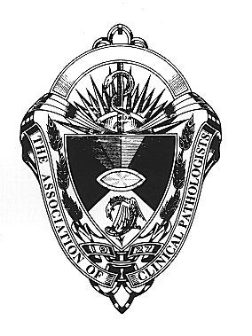
Association of Clinical Pathologists’
International Scientific Meeting

12 & 13 June 2008

Corinthia Towers Hotel, Prague, Czech Republic

Histopathology 12 & 13 June
Errors and why we make them
includes lectures on GI pathology, haematopathology, breast pathology,
uterine and ovarian pathology, prostate cancer

Forensic Pathology 13 June p.m.
Histopathologists and concealed homicide: will I end up in court?

Microbiology 12 & 13 June
includes lectures on virology, mycology and paediatric microbiology

Haematology 12 & 13 June
includes a morphology session,
Updates on IVIg guidelines, Primary Thrombocythaemia and Myelofibrosis, Management of acquired bleeding disorders, Classification of Hodgkin lymphoma, Use of molecular markers in AML management, Mantle Cell Lymphoma, Immune evasion in viral infections,

Chemical Pathology 12 & 13 June
includes lectures on obesity, HIV and dyslipidaemia, Small dense LDL-C,PCOS and the metabolic syndrome, Laboratory IT, Cardiac markers, Why bother with sex?

Plenary lectures 13 June p.m.
Infection matters! Providing safe care in a 21st century health service
Professor B I Duerden
Fraud and errors in clinical research – what matters and what does not
Dr M Buyse
What can Toyota teach us about Pathology
Mr D Ricketts

Presidential address 12 June
Osler in the 21st Century
Dr G P Spickett

Poster presentations 12 June

Free meeting registration for the first 30 applicants from the Czech Republic, Slovakia, Hungary, Poland and Slovenia. Once the 30 scholarship places
have been filled, a rate of £30 per day will apply.

Full details and registration forms can be found on the ACP website
www.pathologists.org.uk or e mail info@pathologists.org.uk
to request a printed programme

